Click to Edit Title That Also Appears in the Footer (Max: 3 Lines or 100 Characters)
Subtitle (optional) may be up to two lines long and is sentence case
Abstract
Limit the abstract to 245 characters, including spaces. This abstract is used as the description when the document is published.
January 2021

Revisions
Date | Description
January 2021 | Initial release

Acknowledgments
Author:
Support:
Other:

The information in this publication is provided “as is.” Dell Inc. makes no representations or warranties of any kind with respect to the information in this publication, and specifically disclaims implied warranties of merchantability or fitness for a particular purpose.

Use, copying, and distribution of any software described in this publication requires an applicable software license.

This document may contain certain words that are not consistent with Dell's current language guidelines. Dell plans to update the document over subsequent future releases to revise these words accordingly.

This document may contain language from third party content that is not under Dell's control and is not consistent with Dell's current guidelines for Dell's own content. When such third party content is updated by the relevant third parties, this document will be revised accordingly.

Copyright © <pub date – rev date> Dell Inc. or its subsidiaries. All Rights Reserved. Dell Technologies, Dell, EMC, Dell EMC and other trademarks are trademarks of Dell Inc. or its subsidiaries. Other trademarks may be trademarks of their respective owners. [8/3/2021] [Document Type] [Document ID]

Table of contents
Revisions 2
Acknowledgments 2
Table of contents 3
Executive summary 4
1 Document type definitions and required content 5
1.1 Reference Architecture 5
1.2 Deployment and Configuration 6
1.3 Best Practices 8
1.4 Technical White Paper 9
2 Style samples <Heading 1> 10
2.1 <Heading 2> 10
2.1.1 <Heading 3> 11
A Configuration details <Appx-Hdg1> 14
A.1 <Appx-Hdg2> 14
A.1.1 <Appx-Hdg3> 14
B Template styles and terminology example 15
C Technical support and resources 17
C.1 Related resources 17

Executive summary
Note: This section is required for Reference Architectures, Best Practices guides, and Technical White Papers. It is optional for Deployment and Configuration guides.
The executive summary includes a problem statement and the Dell Technologies solution that is detailed in the remainder of the paper. It should include key findings and information that gives the reader insight as to why they would be interested in this solution.

<Required section break before first numbered section>

Document type definitions and required content
Note: As a best practice, present the purpose of the paper up front (in the executive summary). Main supporting details belong in the numbered sections. An appendix is used to hold information for the more inquisitive readers. In other words, get the reader’s attention first. The farther they read in the paper, the deeper they dive into details.

Note: Select the document type from sections 1.1 through 1.4 that best fits your content. Be sure to delete all content specific to the template before publishing. Also, confirm that the selected document type (for example, Best Practices) appears in the Document Type field at the top of the title page.

Reference Architecture
The Reference Architecture is a document that is intended for both internal and external consumption. It is purpose built to provide Dell Technologies recommended best practices or other conclusions supported by tested and validated solutions and may include capacity or sizing guidelines. Minimum requirements for a reference architecture are outlined in the following bullet points.
For other content topics that are not listed in this template, use a heading of level two or lower.
The wording of the headings does not have to be exactly as listed; the following list is a representation of the intent for each section. This list also provides the suggested order for these topics which, unless otherwise stated, should be in the main body of the paper:
- Introduction: Provide the audience a summary of the paper, answering these basic questions: What is the problem? Have other approaches failed? What are the key components of this approach and result? Specific limitations may also be included.
- Objective: Include the scope of the document and list areas that are out of the scope to avoid confusion. There is an appendix including additional resources (appendix C) where links to papers that cover the out-of-scope topics can be placed.
- Audience: Describe the intended audience and expected knowledge of the readers.
- Solution or product overview: Keeping the audience in mind, describe the product and its uses. Features and benefits that support the solution can be described. Otherwise, provide a link to the marketing website that lists all the features and benefits for the product. Technical specifications can also be provided here.
- Use cases: Describe a system behavior as it applies to the objective with a focus on successes.
- Test configuration: Provide a description of the variables that make up the configuration required to perform the tests presented. An explanation of why this configuration was required or chosen may also be included.
- Diagrams (at least one of the following types located anywhere in the document)
  - Conceptual: (Logical or functional diagram) A schematic representation including the main logical components of a total system or solution and the relationships among each other. It can span across software, hardware, and network components, but it does not represent, and it is not limited by, the physical components or by the amount of them. The data flow and the directions it might follow should be communicated at the upper layers of a system or solution.
  - Physical: Physical and connectivity diagrams displayed in a schematic representation including the main physical components of a total system or solution and the physical connections among each other. They report the hardware model, and the logistic displacement of the hardware (in a rack diagram). A physical diagram may accept a limited level of abstraction for the representation of the connections (for example, one or more lines representing single or redundant connectivity). In contrast, the connectivity diagram represents port-by-port connections of the physical environment. It usually communicates the data flow happening at the lower layers of a system or solution and the directions it might follow.
Note: A resource for this type of diagram is the Dell library at Visio Café.
  - Component logical detail: (Layout diagrams) A schematic representation including how logical elements of the system or solution (file systems, partitions, and files) are distributed across it.
- Test methodology: Describes the testing and the reasoning used to select the tests run to find the solution presented.
- Results and analysis: State the results of the tests and provide the analysis used to support the conclusion or best practices presented. Performance data charts or graphs with supporting analysis should also follow the brand guidelines. Verify the font used matches the font in the body of the document (Arial, 10-point).
- Best practice recommendations: Provide methods or techniques that have consistently shown results superior to outcomes that are achieved with other means. They are offered to the readers as a method to obtain or maintain quality.
- Conclusion: Shows the reader why the paper was important without only repeating what has already been stated. The conclusion shows how the points made in the paper support the results and how the examples were not just randomly selected.
- Configuration details: (Best suited for an appendix) Describes details about the test configuration that may or may not be important to the reader. See appendix A in this template for a table that provides sample information. The component list in this table is a minimum requirement.
- Terminology: Include terms as needed (including spelling out the first occurrence of acronyms and abbreviations), in a section that provides an alphabetized list of terms and definitions, or both. Optionally, the terminology section can appear at the beginning of the paper as a subsection of the Introduction. Appendix B in this template presents an example as a list of styles that are available in this template.

Deployment and Configuration
Note: The following are topic areas that you may cover in this document (remove this section in final document). If some optional topic areas (specific areas, not all) are used, and step-by-step instructions are included, this document is classified as a deployment guide. If all optional topics are included, the document aligns with the definition of a Reference Architecture (if the step-by-step instructions are reduced).
- Validated configuration
- Diagrams (optional)
- Screen captures: UI or CLI (optional)
- Use cases (optional)
- Results and analysis (optional)
- Competitive analysis (optional)
- Other best practices (optional)
- Deployment and Configuration guide definition
Is | Is not
- Step-by-step instructions for preinstallation site preparation  - Step-by-step installation for hardware deployment and bring up  - Software installation and setup  - Customer-facing PDF (external postings) | - Only best practice recommendations  - Production user manual  - Production configuration guide  - Blogs or Wikis

The Deployment and Configuration guide is a document that is intended for both internal and external consumption. It is purpose built to provide Dell Technologies recommended step-by-step installation, deployment, or configuration instructions that are based on best practices. The instructions are supported by tested and validated engineer configurations and may include a troubleshooting section for assisting the customer in basic self-help steps. Specific configuration files and screenshots can be added to the step-by-step instructions. Use case information is optional. Minimum requirements for a Deployment and Configuration guide are listed in the following bullet points.
For other content topics that are not listed in this template, use a heading of level two or lower.
The wording of the headings does not have to be exactly as listed; the following list is a representation of the intent for each section. The lists shows the minimum content requirements for a Configuration and Deployment document. This list also provides the suggested order for these topics which, unless otherwise stated, should be in the main body of the paper:
- Introduction: Provide a summary of the paper, answering these basic questions: What is the problem? Have other approaches failed? What are the key components of this approach and result? Specific limitations may also be included.
- Objective: Include the scope of the document and list areas that are out of the scope to avoid confusion. There is an appendix that lists other resources (appendix C) where links to papers that cover the out-of-scope topics can be placed.
- Audience: Describe the intended audience and expected knowledge of the readers.
- Solution or product overview: Keeping the audience in mind, describe the product and its uses. Features and benefits that support the solution can be described. Otherwise, provide a link to the marketing website that lists all the features and benefits for the product. Technical specifications can also be provided here.
- Optional sections:
  - Configuration prerequisites: Include configuration prerequisites such as operating system, firmware version, hardware version, and part numbers. You may choose to cover this information in each scenario since it may differ in each scenario.
  - Conclusion: Show the reader why the paper was important without only repeating what has already been stated. Show how the points made in the paper support the results and how the examples were not just randomly selected.
  - Other configuration details: Describe more details about the test configuration that may or may not be important to the reader. See appendix A in this template for a table that provides sample information.
  - Terminology: Include terms as needed (including spelling out the first occurrence of acronyms and abbreviations), in a section that provides an alphabetized list of terms and definitions, or both. Optionally, the terminology section can appear at the beginning of the paper as a subsection of the Introduction. Appendix B in this template presents an example as a list of styles that are available in this template.
  - More resources: See appendix C in this template for an example.

Best Practices
Best Practices guides can be divided into two categories:
- Dell Technologies recommended guidelines to optimize solutions or products.
- Industry-related guidelines which are accepted by industry experts or recognized industry-standards organizations.
Dell Technologies recommended guidelines should be tested and validated by Dell Technologies engineering based on the defined use case. The minimum requirements for a Best Practices paper are listed in Table 2.
- Best Practices guide definition
Is | Is not
- What to do and what not to do  - Product and industry guidance  - Software installation and setup  - Tested and validated practice for the solution  - Example for application template for management interfaces  - Published findings by recognized industry standards organizations  - Customer-facing PDF | - Untested/not validated use cases  - Production user manual  - Production configuration guide  - Only performance data  - Only sizing information  - Unsubstantiated claims  - Blogs or Wikis

For other content topics that are not listed in this template, use a heading of level two or lower.
The wording of the headings does not have to be exactly as listed; the following list is a representation of the intent for each section. The lists shows the minimum content requirements for a Best Practices document. This list also provides the suggested order for these topics which, unless otherwise stated, should be in the main body of the paper:
- Introduction: Give the audience a summary of the paper, answering these basic questions: What is the problem? Have other approaches failed? What are the key components of this approach and result? Specific limitations may also be included.
- Objective: Include the scope of the document and list areas that are out of the scope to avoid confusion. There is an appendix that lists other resources (appendix C) where links to papers that cover the out-of-scope topics can be placed.
- Audience: Describe the intended audience and expected knowledge of the readers.
- Solution or product overview: Keeping the audience in mind, describe the product and its uses. Features and benefits that support the solution can be described otherwise provide a link to the marketing website that lists all the features and benefits for the product. Technical specifications can also be provided here.
- Use cases: Describe a system behavior as it applies to the objective with a focus on successes.
- Test configuration: Describe the variables that make up the configuration required to perform the tests presented. An explanation of why this configuration was required or chosen may also be included.
- Diagrams: If diagrams are needed, the paper becomes a reference architecture (see section 1.1 for descriptions of Reference Architecture diagrams).
- Test methodology: Describe the testing in addition to the reasoning used to select the tests run to find the solution presented.
- Results and analysis: State the results of the tests and provide the analysis used to support the conclusion or best practices presented. Performance data charts or graphs with supporting analysis should also follow the brand guidelines. Verify the font used matches the font in the body of the document (Arial, 10 point).
- Best practice recommendations: Provide methods or techniques that have consistently shown results superior to outcomes that are achieved with other means. They are offered to the readers as a method to obtain or maintain quality.
- Conclusion: Show the reader why the paper was important without only repeating what has already been stated. Show how the points made in the paper support the results and how the examples were not just randomly selected.
- Configuration details (best suited for an appendix): Describe details about the test configuration that may or may not be important to the reader. See appendix A in this template for a table that provides sample information. The component list in this table is a minimum requirement.
- Terminology: Include terms as needed (including spelling out the first occurrence of acronyms and abbreviations), in a section that provides an alphabetized list of terms and definitions, or both. Optionally, the terminology section can appear at the beginning of the paper as a subsection of the Introduction. Appendix B in this template presents an example as a list of styles that are available in this template.

Technical White Paper
Technical White Papers can include performance data, competitive comparisons, benchmarking, industry analysis, or recognized standards organization reports. This category should only be used if none of the others apply.
- Technical White Paper definition
Is | Is not
- Tested and validated claim results  - IDC or Gartner reports  - Third-party vendor reports (Principled Technologies)  - Industry benchmarks from industry publications (magazine reviews)  - Customer-facing PDF | - Untested/not validated claims (marketing claims only)  - Product user manual  - Product configuration guide  - Blog or Wikis

Style samples <Heading 1>
All headings and captions are sentence case (not title). All level-one headings appear at the top of the page.
The following note is a predefined style called Note. It can be used for essential information that needs the reader’s attention. It is not a text box.
Note: <Note>

<Heading 2>
<Normal>
- For a numbered list, use the <Numbered(1)> style.
  - To change indention of items, use the <Numbered(a)> style or the increase (or decrease) indent buttons .
    - To achieve a third-level indention, use the <numbered(i)> style or the increase (or decrease) indent buttons .
- Back to main level.
This style is <Normal indent>.
More text:
- Style: <List Bullet>
- Another bullet
  - Style: <List Bullet 2>
    - Style: <List Bullet 3>
- Style: <List bullet>
Use bold (not italics) to emphasize a term or mention a menu item. For example: To apply bolding, highlight the item and click Home > Font > Bold or press Ctrl + B.

Note: The following table is an example. Tables can be used at any point in the document and do not need to be used for a specific section.
- <Caption(Table)>
Table heading | Table style: “Dell”
All cells use the <TableCell> style | Set the table style from the Table Tools > Design tab and select Dell.  bold headings are automatic with this table style.
Table captions appear above the table using the Caption(Table) style. | The table can have an empty return following it to give space between the table and the following paragraph.*
Ordered list in a table | - <Table Number>  - Continued
Unordered list in a table | - <Table Bullet>  - Continued
* The paragraph immediately following a table can be used for a footnote reference in the table.
When code or script is listed in a document, use <Code> or <CodeIndent> as appropriate.
Example of the code style
Example of the CodeIndent style
When code is included in line with a sentence, do not apply the <Code> style (continue using <Normal> style) and apply bolding to the code segment.

<Heading 3>
<Normal> In general, papers should not use headings that proceed deeper than a heading 3. However, a heading 4 style is provided in this template if its use is unavoidable.
Use the style <Graphic> for the paragraph holding an image.
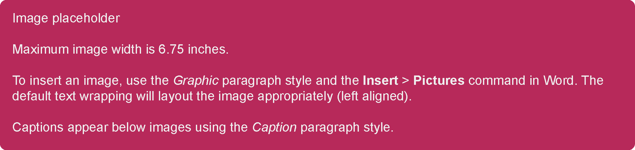
- <Caption> Image description
Note: The maximum width of a graphic is 6.75 inches. The font in the graphic should be Arial 10 pt. so that it matches the normal text in the rest of the paper. All graphics should follow the direction of the brand guidelines at http://brand.delltechnologies.com (may require login).
General guidelines to consider when creating a graphic include the following:
- Use only approved Dell Technologies photography or Visio stencils or iconography.
- Both photos and stencils are permitted within the same document.
- Photos are best suited for introducing the product or showing real images of the product in use.
- Stencils are best used for wiring diagrams.
Links to images approved for use in Dell Technologies material:
- Product photography on the DAM
- Link to all Dell Stencils on visiocafe.com

Avoid using this heading level unless necessary
Instead of beginning a section with a graphic, table, or list, use an introductory sentence. For example, Figure 2 displays a collection of sample Dell Technologies icons.
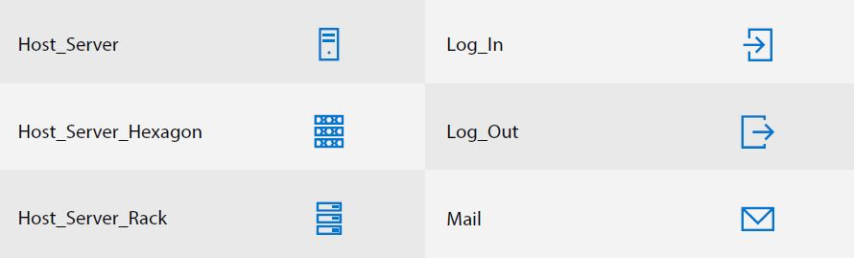
- Sample Dell Technologies icons

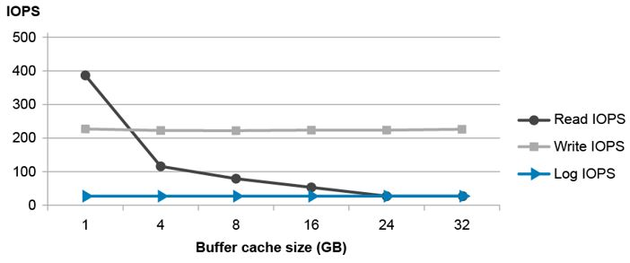
- Graph title goes here
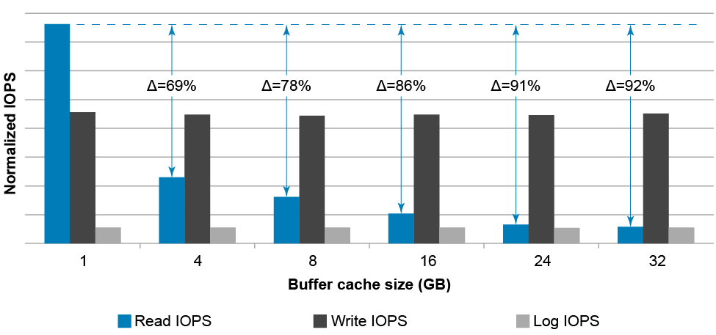
- Graph title goes here

If a table needs more room on a page than the normal table allows, use the Dell-Wide table style. The same Caption(Table) style is used before the table.
- Wide table
Column 1 heading | Column 2 heading | Column 3 heading | Column 4 heading | Column 5 heading
Lots
 | of
 |  | essential
 |  |  | information
 |  |  |  | here

<Required section break before first appendix>

- Configuration details <Appx-Hdg1>
Note: As a best practice, present the purpose of the paper up front (summary). The main supporting details belong in the numbered sections. An appendix is used to hold information for the more inquisitive readers. In other words, get the reader’s attention first, and the further they read in the paper, the deeper they dive into the details.
- Component table example
Component | Description
Operating system | Operating system type, patch level, service pack, hypervisor
Driver version | NIC driver, storage drivers
Firmware version | NIC, RAID, switch, firmware versions
Application | SQL Server, Oracle; includes management applications (OMSA, SANHQ)
Cabling | If applicable, power, network, or other cabling
Server | Server type, CPU type, memory, internal disks
Storage | Model, disk type, and number
Switch | Model, and switch firmware or operating system

  - <Appx-Hdg2>
    - <Appx-Hdg3>

- Template styles and terminology example
Terms may be defined as they appear in the paper (including spelling out the first occurrence of acronyms and abbreviations). Terms are defined in a section that provides an alphabetized list of terms and definitions, or both. Optionally, you can place the terminology section at the beginning of the paper as a subsection of the Introduction.
The following definition list describes the styles available to achieve the format in this template. These styles have been added to the Styles gallery (Home > Styles) for your convenience.
AbstractBody: Appears on the cover page after the AbstractTitle. This information can be used for the description on the publishing website.
AbstractTitle: Appears on the cover page below the subtitle.
Appx-Hdg1, Appx-Hdg2, and Appx-Hdg3: Appendix headings (levels 1 to 3). Level 1 appears at the top of a page. The headings are represented by an alpha character. Name an appendix the same as other headings (it should not be Appendix A because that is not descriptive to the content).
Caption: Figure label. Figure captions are shown below a figure (using the Graphic style) and provide a place to give an appropriate label to identify the image.
Caption(Table): Table captions are shown above a table and provide a place to give an appropriate label to identify a table. NOTE: All tables should have the Dell or Dell-Wide table style implemented.
Code and CodeIndent: Use these styles to display lines of code or other user input.
disclaimer: The disclaimer style is only used for the copyright notice and other legal text.
DocType: The document type listed at the top of the title page (for example, Reference Architecture). Note: To edit the document type, double-click the title page header and click the Document Type text box.
Footer: Only used in the document footer on page 2 onward.
FooterTitlePg: Only used in the document footer on the title page.
Graphic: This paragraph is used to hold images only and should be followed by a caption paragraph style. It is left aligned with the normal text. The maximum width of a graphic is 6.75 inches. If a graphic exceeds this width, try to shrink or crop the image (recommended) or adjust the left indentation as needed (do not move the indentation within the left margin). Follow this Graphic style with a Caption-styled paragraph.
Heading: Use for the heading of a section that is not required to be part of the numbered outline (for example, Executive summary).
Heading 1, Heading 2, Heading 3, and Heading 4: Section headings (levels one through four) in the main flow of the document. Heading 1 appears at the top of a page. All headings are represented by a numeric counter. As a best practice, heading level 4 should only be used if it is unavoidable by rearranging the content.
List Bullet, List Bullet 2, and List Bullet 3: Bulleted list levels one through three. Use these styles for a list of items or topics that do not need to follow a specific order. A bulleted list (like the headings and numbered lists) should not have levels deeper than three.
Normal: Used for regular paragraph text.
Normal Indent: Commonly used for a follow comment under a numbered or bulleted list. This style mimics Normal with an extra 0.5-inch indention.
Note: Use this style to draw the reader’s attention. It mimics and lines up with the Normal paragraph style with the addition of a gray background.
Numbered(1), Numbered(a), and numbered(i): Numbered list levels one through three. Use for lists that must follow a specific sequence. A numbered list (like the headings and bulleted lists) should not have levels deeper than 3.
Subtitle: Only used on the cover page directly following the Title.
Table Bullet: Use for a bulleted (unordered list) within a table. Note: All tables should have the Dell or Dell-Wide table style applied.
Table Number: Use for a numbered (ordered list) within a table. Note: All tables should have the Dell or Dell-Wide table style applied.
TableCell: All text within a table that is not part of a list. Note: All tables should have the Dell or Dell-Wide table style applied.
TextBox: Use this style if you need to create text box, for example, a callout on top of an image.
Title: Only appears on the cover page. The title should represent the most important information about the document.
- Technical support and resources
Dell.com/support is focused on meeting customer needs with proven services and support.
  - Related resources
<Provide a list of documents and other assets that are referenced in the paper; include other resources that may be helpful.>

